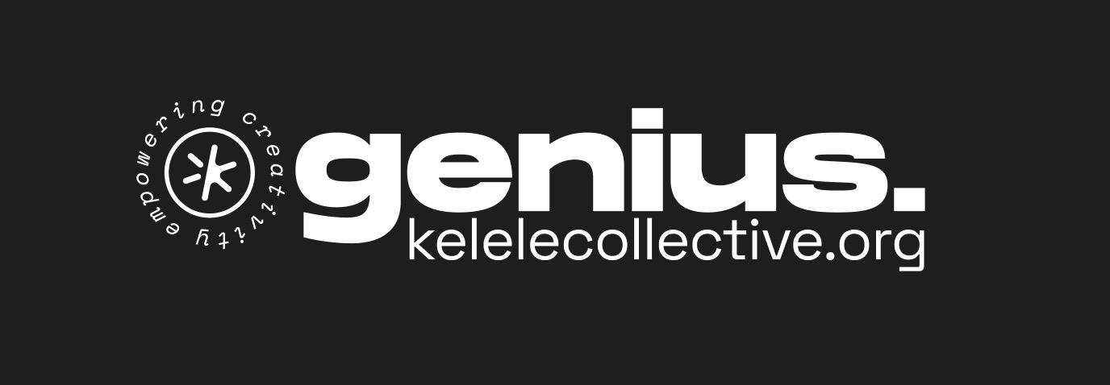

Concept

Mission

🧠 Make it easy to find vetted Ugandan creators
A platform that provides independently verified profiles of Uganda’s multimedia professionals. Kelele Collective acts as a trusted intermediary, opening up our network to recommend the right creators for the job at hand. Proudly Ugandan.
- Provide a trusted pathway to job recommendations
- Offer unbiased, quality-based recommendations
- Link the right producers with the right talent
- Increase Job opportunities for creatives

Key Questions
- Why are existing Platforms (linkedin, artstation etc. not sufficient??)
> Trust problem, no vetting
> Creators not active enough on Linkedin
- Where to limit? Multimedia only?

The Problem We Solve
Existing platforms like LinkedIn and ArtStation don't solve the trust problem. There's no vetting, creators aren't active enough on professional networks, and clients have no reliable way to assess quality or professionalism. Kelele bridges this gap.
The promise to clients:
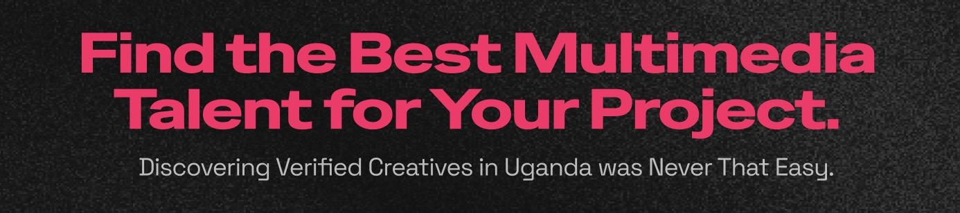

Add Knowledge & Ressources
- Booking Tools
- Contract templates
- Help Users (Clients, Producers to write better briefings) > Create pdf-briefing from filling a form…
- Blog: Articles mirrored on Linkedin, Promote Podcast etc.

Who is Kelele Collective
Kelele Collective is on a mission to empower creatives to become successful professionals through community activities, trainings and mentorship.
We are home to the Multimedia Meetup, a physical event happening regularly in Kampala.
Kelele collective is a registered Non-Profit in Uganda and Switzerland, initiated by Tobias Fluck around 2022, an expat Motion Designer with a background in Design and Advertising based in Kampala.
Read more on kelelecollective.org/hello

Vetting Framework

"Kelele Verified" is our quality mark. It signals that a creator has been reviewed and meets our standards for professional work.

Vetting Criteria
Stage | Criteria | What It Means | Evidence Required
1 | Authenticity, Legitimacy | works beeing made by the creator | Reverse search,  3rd party confirmation
2 | Portfolio Quality | Work samples meet professional standard | Minimum 3 relevant pieces
2 | Skill Accuracy | Creator can do what they claim | Portfolio matches stated skills
2 | Recency | Active and current work | Work from last 2 years (preferred)
 | Network Connection | Known to Kelele community | Bonus trust signal

Scenarios

Scenarios
Evaluation | Way forward
Falsehoods | Reject, request proof,
Originality in question (templates, copied etc.) | Reject, feedback
Quality of work substandard | Reject, feedback > “Not yet”
Quality of work substandard in one area | Reject, let adjust the
Work

Profile/Application Statuses
Level | Description
Pending | Needs evaluation
Rejected soft | Minor flaws | Minor Updates required
Rejected hard | Major flaws.  Substandard | Feedback, Re-evaluation pending for 3 months
Verified  Emerging | “Yung Guns” | Promising Talent, give a chance on the plattform, labeled as “Emerging”
Verified |  | Yearly reminder to keep profile updated  + Survey for feedbacks

Level | Description | Typical Signals
1 | Young gun - Emerging | Some promising work, limited client experience
3 | Expert | Exceptional work, known reputation, complex projects

Quality / Evaluation
We DON’T pit creatives agains each other on the platform (like in the form of a ranking). The philosophy is more about finding the RIGHT provider for our finders projects, rather then the absolute best in the whole country.
Optional datapoints beside can be considered:

Levels

Review Process
Phase 1: Tobi reviews all applications using the vetting checklist.
Phase 2+: Peer review system with additional expert reviewers to scale.

"Not Yet" Framework
Rather than rejecting applicants who don't meet standards, we use a "Not Yet" approach that fits Kelele's mission of empowering creatives. This turns rejection into mentorship.
When someone doesn't pass:
- Acknowledge their application and thank them
- Be specific about what's missing
- Give actionable next steps to improve
- Invite them to reapply in 3-6 months

"Not Yet" Feedback Template
Subject: Your Kelele Collective Application
Hi [Name],
Thanks for applying to be listed on Kelele Collective—we're glad you want to be part of this.
After reviewing your profile, we're not able to verify you just yet. Here's why:
What's missing: [Select/edit as needed]
- We'd need to see more work samples (minimum 3 pieces)
- Your samples don't clearly demonstrate [skill they claimed]
- We'd like to see more recent work (ideally from the last 2 years)
- The work isn't quite at the quality level we're verifying for yet
What would help: [Add 1-2 specific suggestions]
- Example: "Stronger examples of motion graphics with more complex animation"
- Example: "A short film or commercial project that shows your cinematography range"
This isn't a "no"—it's a "not yet." You're welcome to reapply in 3-6 months with updated work. In the meantime, keep creating.
[Optional: If you'd like feedback or mentorship, join us at our next Multimedia Meetup—details at kelelecollective.org.]
Best,[Tobi / Kelele Collective]

Profiles

Visuals: Images, Videos embedded
Personal: Full Name, Artist Name, Contact, Location, own Company (Founder, or co-Founder)
Links: to PDFs, Websites and Social Channels (External)
Skills (Disciplines): Main Skill – Several Side Skills possible (cap of 3?)
Experience: In Years per skill:
(this can act as a price-range indication)
Specialities: Content Creation, Film/TV, Music Industry, Advertising, Fashion, Art, Gaming, Comic, Editorial, Architecture, Documentary, Educational, Media for Kids (up to 5?)
Software: List of Applications (keep compact in Profile)
Services: “What I offer” (AS A TEXTFIELD) Freelaning, Gigwork, Production-Management, Ideation and consulting, Event-Films complete with Audio Production

Certificates/Schools: We don’t beleive in certificates for creatives

(( Mamybees…
Clients I have worked for: how to vett?
>> Individuals vs. companies? // Single Freelancer or Production Team ))

Skills >> See Onboarding

Research
GPT on multimedia creators market: https://chatgpt.com/share/6936f7af-0544-8006-a31c-946d560f9de1

Alternatives / Competition
Global platforms: Behance, Dribbble, Upwork, Fiverr
Africa Focused:
- https://africacreators.com > funding proposal, no info on background
- https://newcomma.com > “Black-focused” artist plattform (NO Opportunities for Uganda)

Inspiration
Rolo.works / https://rolo.works/blog
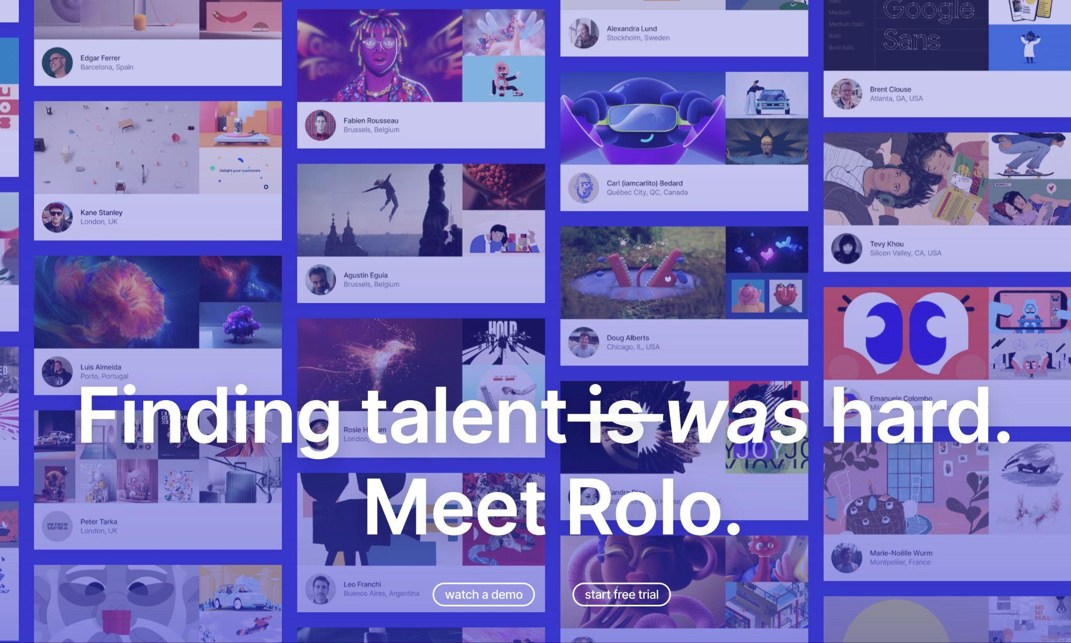
Fiverrr, Behance:
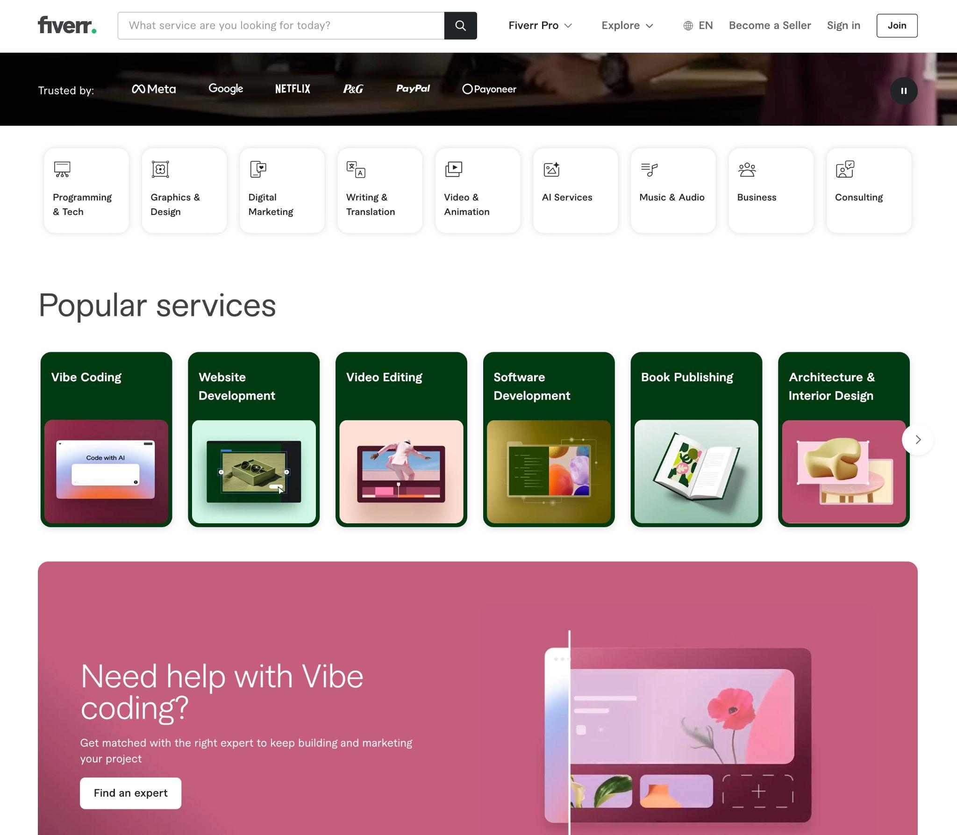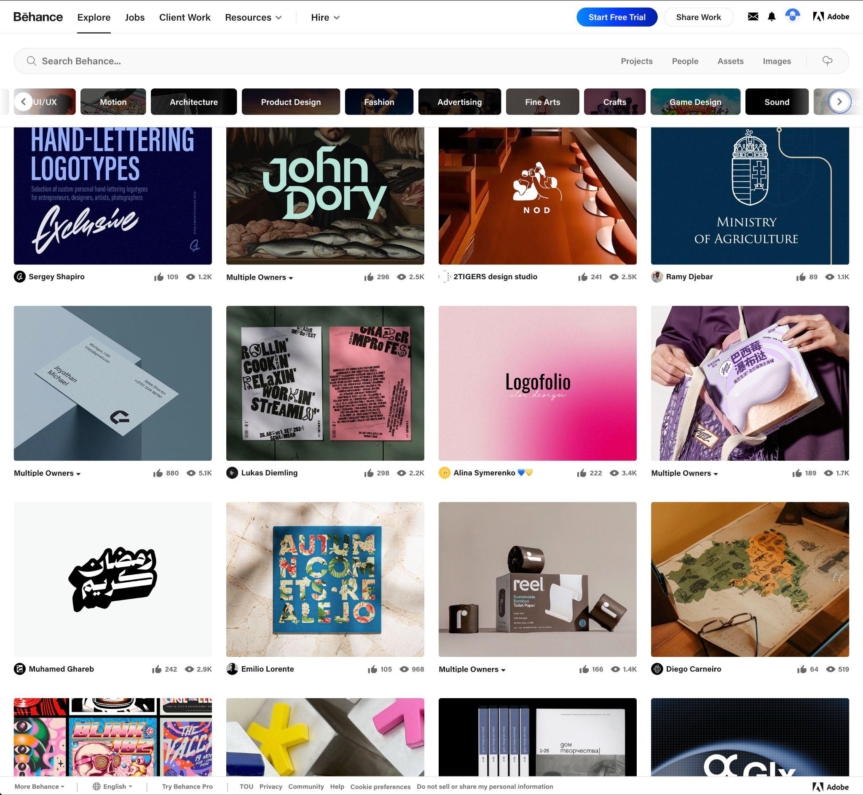
Profile example rolo:
https://app.rolo.works/artist/gtimeyin
https://app.rolo.works/artist/dreilly
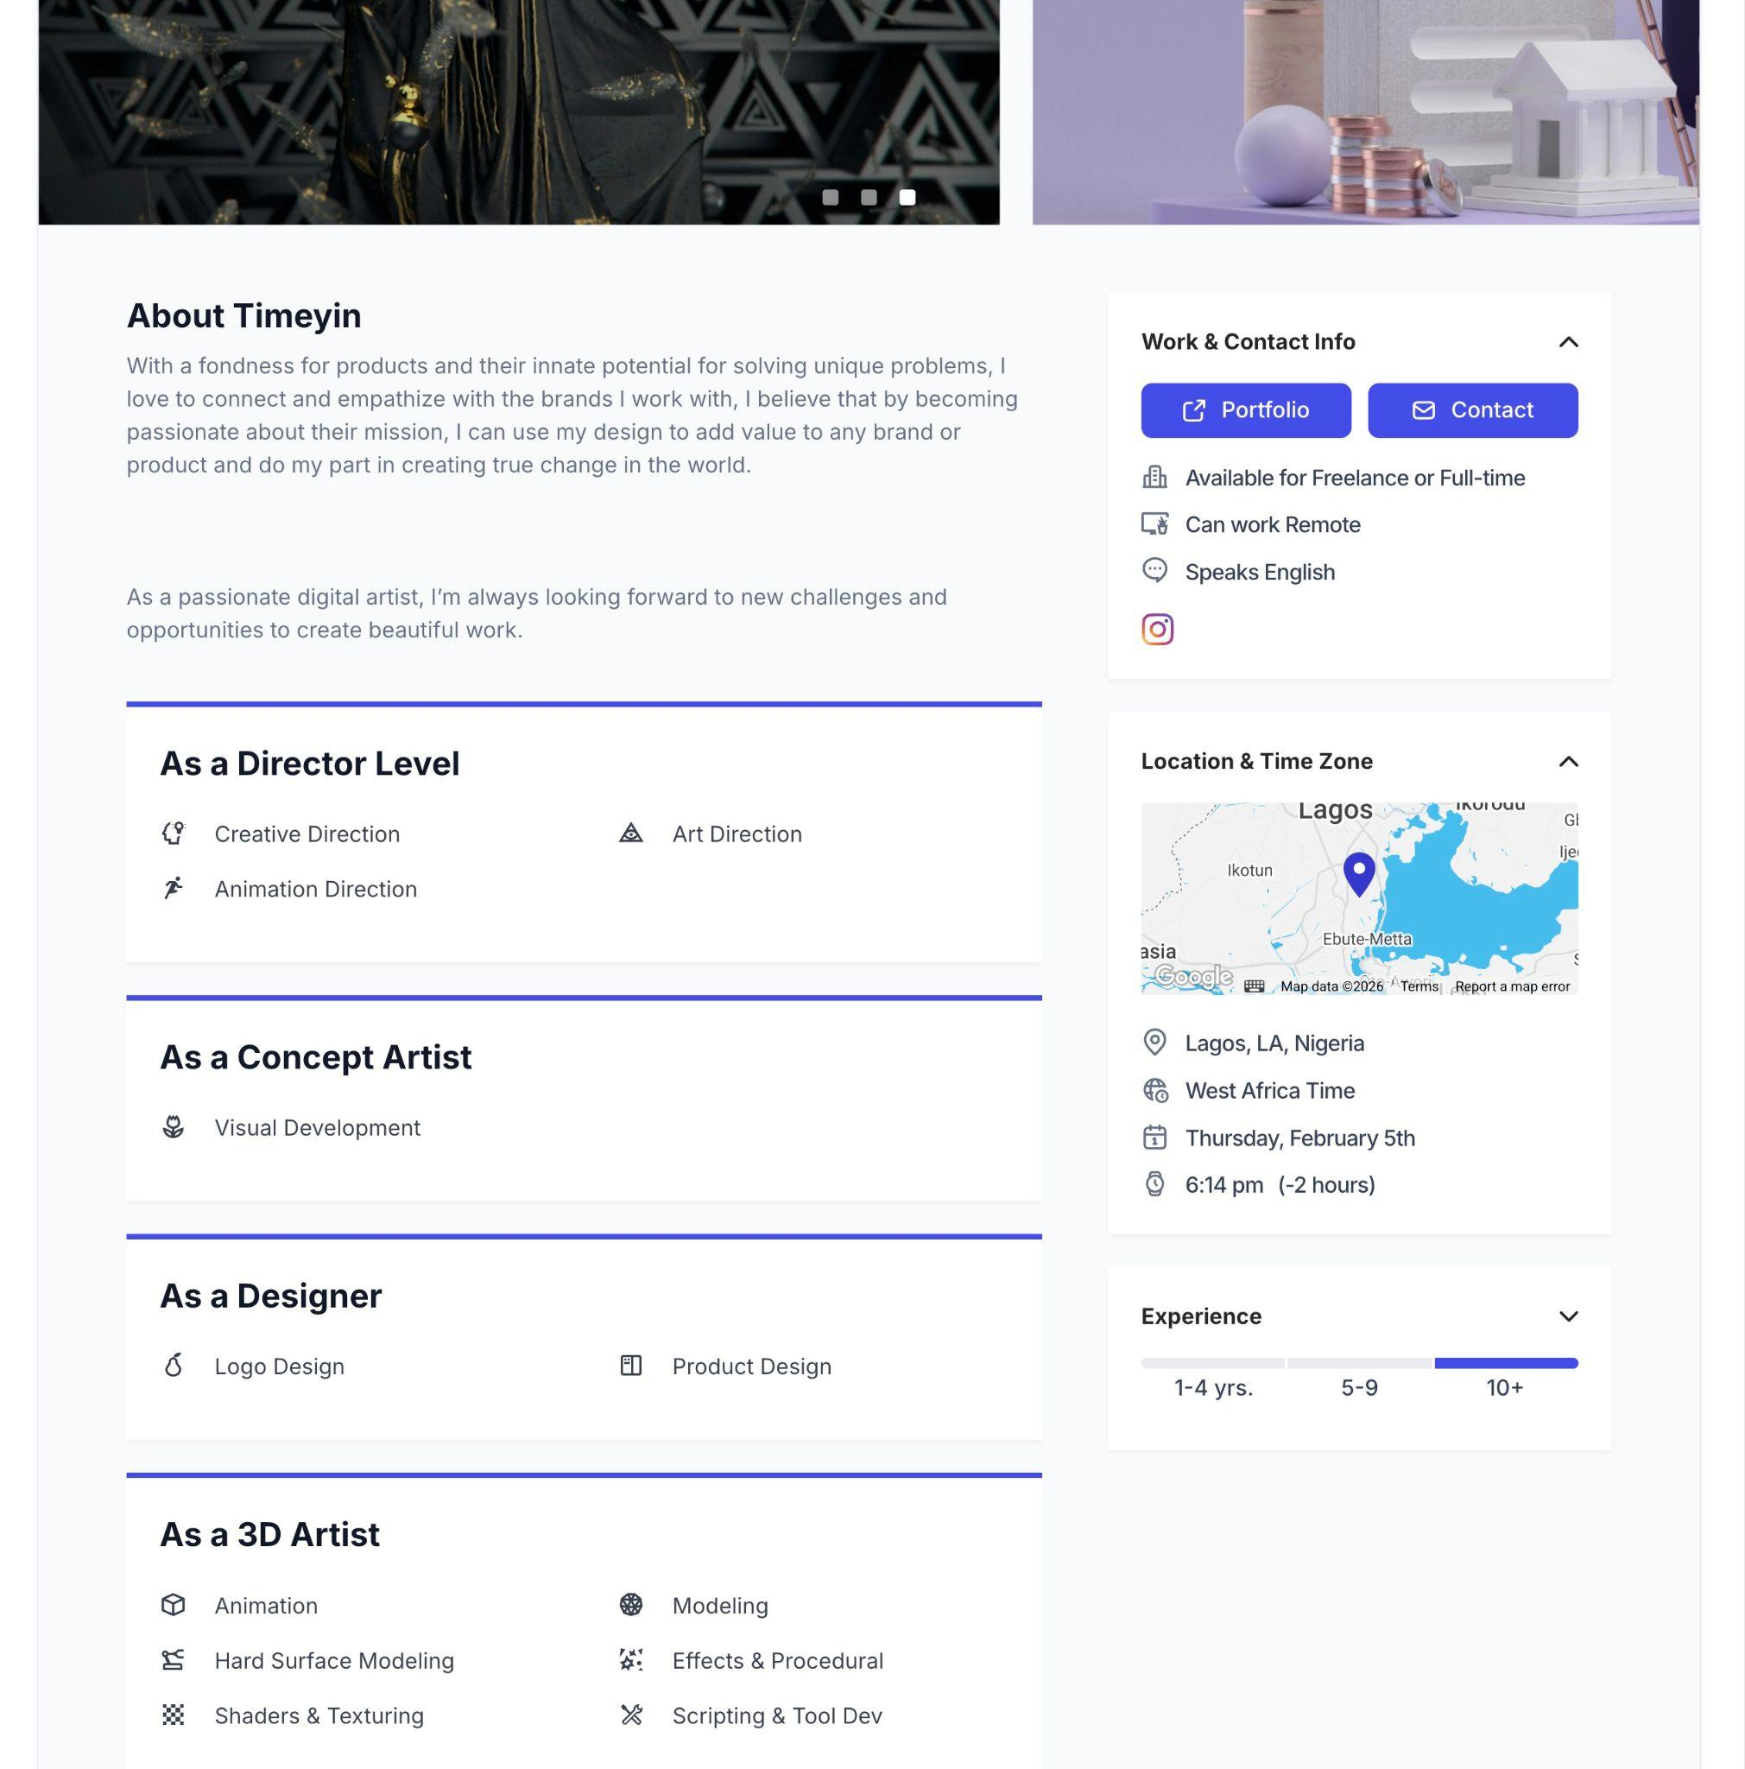

Design

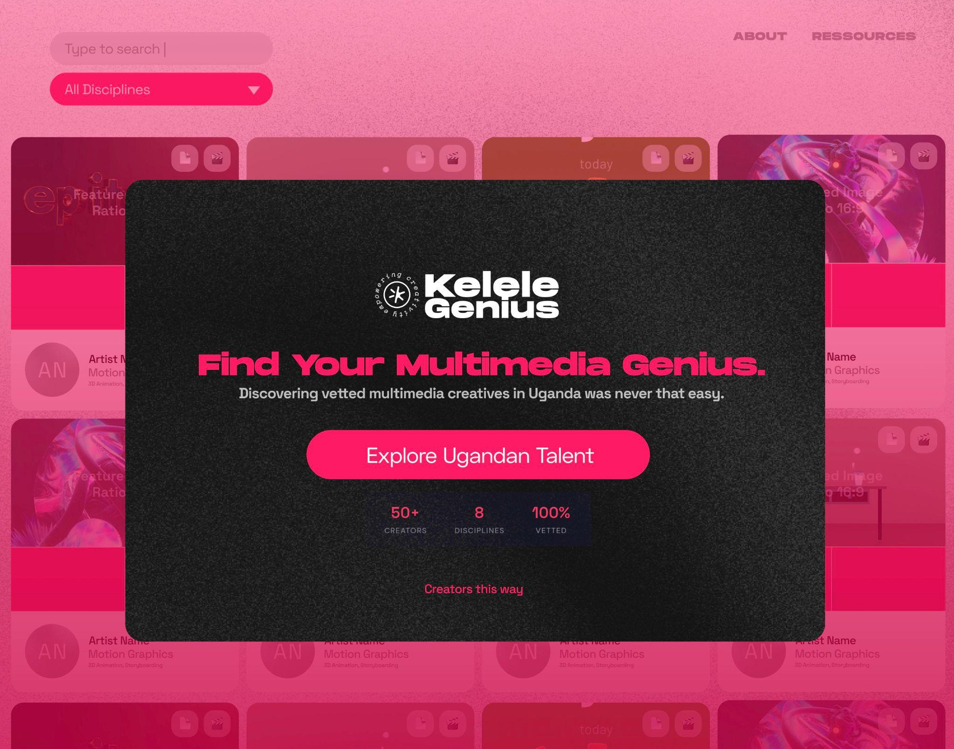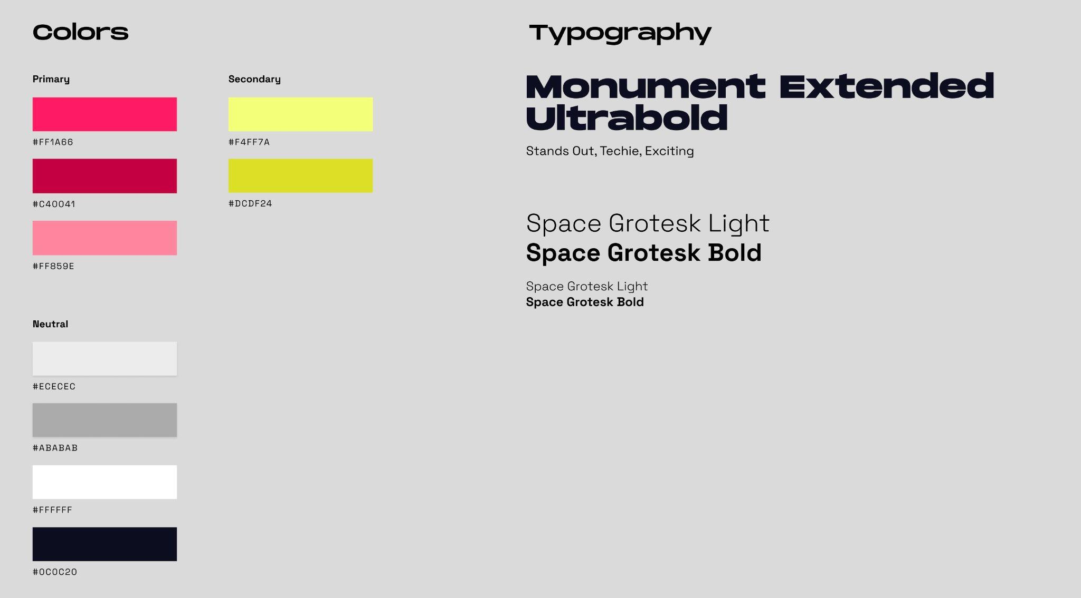
Headline Font: Monument: https://pangrampangram.com/products/monument-extended#buy
Free: https://unblast.com/download/50720
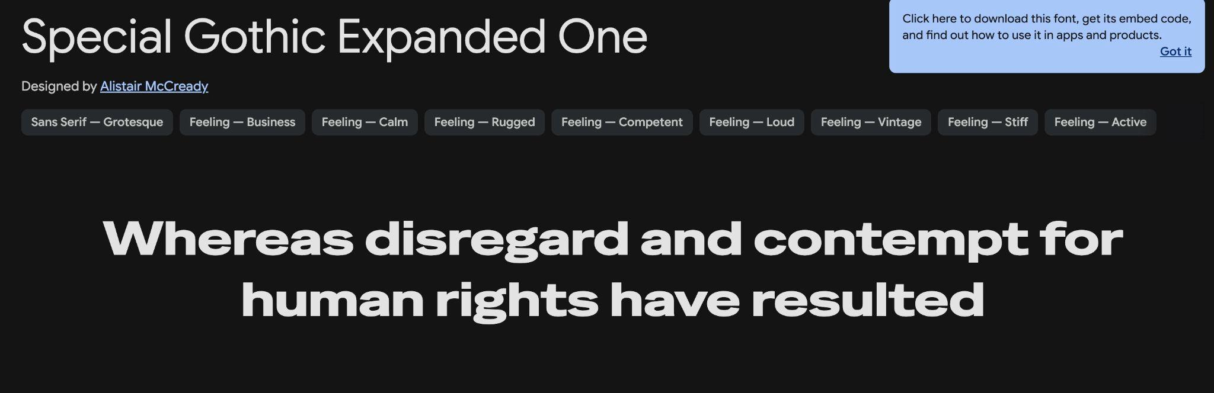
Google Font Alternative: https://fonts.google.com/specimen/Special+Gothic+Expanded+One

Budget / Financing?
Monetisation Options:
- Sponsored: Grant/Sponsorship to develop – and keep platform free
- Subscription (not so good, cause not reocurring clients)
- Freemium: Paywall for certain information (unlock for 1 month at a time)
- Comission: Pay for sucessful recommendations

Promotion
- Stories on Linkedin
- Whatsapp and Faceboook Groups for Expads like KLA Remainers etc.

- Campaign Ideas around Game-Character Score Cards
- Testimonials from Producers/Clients
- Walk-trough-screen-vids

Team/Roles
Product Lead  Vision, Concept  Finances  Tobi | Coding  Architecture  Toliva | Design?  UI  Brand  Promotion

Development

Creator Profiles (Ideas)
Mininmal >> Profile Categories/Wireframe below
- Work samples / visuals
- Company Name option
- Profile Pictures
- Main Category/Skill, Side Skills
??
- How to automate Visual representation Link to portfolio free sites?
  - Artlink, Behance, Shared Google Folder, Youtube, Integration of Linkedin-Elemets? (Certificates)
  - Akatuuti
Nice / Ideas
- Make a VERIFIED-Label,
- Price-point Indicator (per skill?),
- Fun generated avatars when profile pic is missing
- Software Skills (> pretty hard to vet)
- Software categories with individual levels
- Level Indicator for each Skill seperately
- Certificates, Education
- Localisation
- Automated Email- / whatsapp-campaig to keep profiles updated

Onboarding Creators
- Problem: Time to capture manually
- Automate Profile capturing
- Taking People by the hand when filling their profile > Guide with Examples etc.
- How to keep up to date: Email with automated call to update to all in data-base
Nice / Ideas
- Let Artists capture their information through form

Searcher Accounts = User
Mininmal >> not for first stage
Nice / Ideas
- Create Favourites-Lists
- Anonymous Evaluations / Feedbacks
- Offer custom recommendations

Filter / Search / Categories
Main Skill Categories (Profile can have one Main skill (up to 3 side skills
- Photography
- Cinematography
- Editing
- Illustration
- 2D Animation
- 3D Animation
- Motion Design
- Graphic Design Print
- Graphic Design Online
- Programming
- Producing
- Writing
- Art direction
- Scenography

Skill Level
Software
- Level 0 - 3
- 0 = First timer
- 1 = Beginner
- 2 = Intermediete
- 3 = Pro

Experience? (needs to be vetted)
- Former clients, Size of budgets, Years of experience

Progress & Todo

Dev-Stages
Phase 1 – Proof of Concept
- Finalize Concept paper and vetting criteria
- Define Categories and profile-needs
- Rough Wireframe Layout
- Backend: Supabase (PostgreSQL database)
- Manual onboarding process
- 50 creatives onboarded
- MVP: Database, Profiles, Filter, Basic Onboarding

Phase 2 – Build out
- Fundraising: Find a grant
- Start search via custom form (step-by-step process)
- Automation of onboarding
- Peer review system
- Scale to 500 creatives

Phase 3 – Refine and Scale
- Enhanced interface
- User accounts with favorites and history
- Monetization implementation

Todo Tobi
- Write Basic Concept + Goals / Objectives
- Development Stages / Priorities
- Market Research
- Mockup Onboarding Form
- Naming & URL
- Define evaluation criteria
- T&Cs (+ Policy for Creators)
- Client/Searcher-Form to streamline requests

Todo Toliva
- Mini-Prototype
- User Story for Creators
- Decide on Architecture
- What to build, where to use third-party tools (like google forms)
- Intergrate work samples

Technical Architecture
Backend: Supabase (PostgreSQL) — provides database, admin UI, CSV export, and API for the frontend.

Database Schema

creators
Main profile information for each creative.
Column | Type | Notes
id | uuid | Primary key
name | text | Full name
email | text | Private — admin/clients only
phone | text | Private — admin/clients only
company_name | text | Optional, public
profile_photo_url | text | Public
bio | text | Short description, public
location | text | City/area, public
price_range | text | "budget", "mid", "premium"
portfolio_behance | text | Optional
portfolio_youtube | text | Optional
portfolio_instagram | text | Optional
portfolio_linkedin | text | Optional
portfolio_website | text | Optional
portfolio_other | text | Catch-all for other links
is_public | boolean | Show on directory after vetting
created_at | timestamp | When they applied
updated_at | timestamp | Last profile update

creator_skills
Links creators to their skills (one main, up to 3 side skills).
Column | Type | Notes
id | uuid | Primary key
creator_id | uuid | Foreign key → creators
skill | text | From skills_list
is_primary | boolean | Main skill = true
level | int | 1 (Emerging), 2 (Competent), 3 (Expert)

vetting
Tracks review status for each creator.
Column | Type | Notes
id | uuid | Primary key
creator_id | uuid | Foreign key → creators
status | text | "pending", "verified", "not_yet"
reviewer | text | Who reviewed
reviewed_at | timestamp | When reviewed
notes | text | Internal feedback
reapply_after | date | For "not_yet" cases

portfolio_items
Individual work samples linked to a creator.
Column | Type | Notes
id | uuid | Primary key
creator_id | uuid | Foreign key → creators
title | text | Project name
url | text | Link to work
thumbnail_url | text | Preview image
skill | text | Which skill this demonstrates

skills_list
Reference table of available skill categories.
Column | Type | Notes
id | uuid | Primary key
name | text | e.g. "Photography", "Motion Design"
is_active | boolean | Can disable without deleting

Data Privacy
- Private fields (email, phone): Only visible to admins and logged-in clients
- Public fields: Visible on directory after creator is verified and is_public = true
- Vetting notes: Internal only, never shown to creators or clients

User Stories

Creator
I want to... | So that...
Submit my profile with work samples | I can be considered for the directory
List my main skill and side skills | Clients find me for the right jobs
Add links to my portfolio platforms | Clients can see more of my work
Indicate my price range | I attract clients with matching budgets
Get clear feedback if not approved | I know how to improve and reapply
Update my profile when I have new work | My listing stays current

Client – “Finder”
I want to... | So that...
Filter creators by skill category | I find people with the right expertise
Filter by skill level | I match project complexity to experience
Filter by price range | I find creators within my budget
View a creator's work samples | I can assess quality before reaching out
See portfolio links (Behance, YouTube, etc.) | I can explore their full body of work
Get contact info for verified creators | I can reach out directly

Admin
I want to... | So that...
See all pending applications | I can review new creators
Review portfolio samples | I can assess quality
Assign skill levels (1-3) | Clients can filter by experience
Mark creators as "verified" or "not yet" | Only vetted profiles go public
Add internal notes on each creator | I remember context for future reviews
Export creator data to spreadsheet | I can analyze or share offline
Set a reapply date for "not yet" creators | I can track when to follow up

🚀 © Kelele Collective, Tobias Fluck


